
RAJALAKSHMI INSTITUTE OF TECHNOLOGY
(An Autonomous Institution, Affiliated to Anna University, Chennai)

DEPARTMENT OF ARTIFICIAL INTELLIGENCE AND DATA SCIENCE
ACADEMIC YEAR 2025 - 2026
SEMESTER IV
AL23421 - MACHINE LEARNING LABORATORY
MINI PROJECT REPORT

REGISTER NUMBER | 2117240070014
NAME | AKASH K
PROJECT TITLE | MediCheck – AI Powered Health Risk Prediction & Awareness Tool
DATE OF SUBMISSION
FACULTY IN-CHARGE | Mrs. M. Divya

Signature of Faculty In-charge Signature of HoD

INTRODUCTION
Machine Learning (ML) is a subset of Artificial Intelligence that enables systems to learn patterns from data and make predictions without being explicitly programmed. In this project, the MediCheck system uses a Random Forest Classifier, which is an ensemble learning algorithm. It works by combining multiple decision trees to improve prediction accuracy and reduce overfitting.
For the given problem of disease prediction based on symptoms, this algorithm is highly suitable because:
- It can handle multiple input features (symptoms)
- It works well with categorical and non-linear data
- It provides robust and accurate predictions even with noisy medical data
In MediCheck, symptoms provided by the user are first converted into a machine-understandable format using MultiLabelBinarizer, and diseases are encoded using LabelEncoder. The Random Forest model then learns the relationship between symptoms and diseases to predict the most probable illness.
The problem addressed in this project is the difficulty people face in understanding their symptoms and identifying potential health risks early. Many individuals lack immediate access to medical professionals, leading to delayed diagnosis or misinterpretation of symptoms. This issue is especially critical in regions with limited healthcare access.
MediCheck aims to solve this problem by providing:
- Early health risk prediction based on symptoms
- Personalized insights for better awareness
- Quick and accessible guidance without needing immediate medical consultation
The objective of this project is to develop an intelligent, user-friendly system that assists individuals in understanding possible health conditions and encourages timely medical attention, thereby promoting preventive healthcare and informed decision-making. In addition to prediction, the system enhances user understanding by providing probable disease outcomes along with basic health insights. This helps users become more aware of their condition and encourages them to seek professional medical advice when necessary.
The model is trained on a dataset containing various symptoms and corresponding diseases, allowing it to identify hidden patterns and relationships. By using a Random Forest Classifier, the system ensures better generalization and accuracy compared to single-model approaches.
Overall, MediCheck serves as an intelligent health assistant that bridges the gap between symptom observation and medical consultation, promoting preventive healthcare and early diagnosis.
PROBLEM STATEMENT
Identifying diseases based on symptoms is a challenging task for many individuals due to lack of medical knowledge and limited access to healthcare professionals. People often misinterpret symptoms or ignore early warning signs, which can lead to delayed diagnosis and serious health complications.
There is a need for an intelligent system that can analyze multiple symptoms and provide accurate, quick and accessible disease predictions. The problem is to develop a machine learning-based solution that takes user symptoms as input and predicts possible diseases, helping users gain early awareness and make informed decisions about seeking medical care.
GOAL
The goal of this project is to develop an intelligent and reliable system that can predict possible diseases based on user-provided symptoms using machine learning techniques. The expected result is an accurate and efficient prediction model that assists users in identifying potential health conditions at an early stage.
The system aims to provide:
- Accurate disease predictions based on multiple symptoms
- Quick and real-time analysis for immediate feedback
- User-friendly interaction for easy symptom input and understanding
Additionally, the project opens up several possibilities, such as:
- Enhancing healthcare accessibility, especially in remote or underserved areas
- Supporting preventive healthcare by promoting early diagnosis
- Integrating with advanced technologies like mobile apps, wearable devices, or telemedicine platforms
- Expanding the model with more medical datasets for improved accuracy and wider disease coverage
Overall, the goal is to create a scalable and practical solution that bridges the gap between symptom awareness and professional medical consultation.
THEORETICAL BACKGROUND
Disease prediction based on symptoms is a multi-class classification problem in machine learning. Given a set of symptoms $X=\{x_{1},x_{2},...,x_{n}\}$, the objective is to predict the corresponding disease label $y$from a set of possible diseases.
The model learns a mapping function:
$$f(X)→y$$
where:
- $X$= input feature vector (symptoms)
- $y$= predicted disease class
Since multiple symptoms can occur together, the data is first transformed into a binary vector using encoding techniques, where:
$$x_{i}=\left\{\begin{matrix}1, & \text{if symptom is present} \\ 0, & \text{otherwise}\end{matrix}\right.$$
Random Forest is an ensemble learning method that builds multiple decision trees and combines their outputs. Each decision tree is trained on a random subset of data and features. The final prediction is obtained using majority voting:
$$\hat{y}=\text{mode}(h_{1}(X),h_{2}(X),...,h_{k}(X))$$
where:
- $h_{i}(X)$= prediction from the $i^{th}$decision tree
- $k$= total number of trees
Gini Index (Splitting Criterion)
Random Forest commonly uses the Gini Index to measure impurity:
$$Gini=1-\sum_{i=1}^{n}{p_{i}^{2}}$$

where:
- $p_{i}$= probability of class $i$
Lower Gini value indicates better node purity.
Various machine learning algorithms have been applied to disease prediction systems. Decision Trees are widely used due to their simplicity and interpretability, but they tend to overfit when the dataset is complex. Naive Bayes is a probabilistic classifier that performs well with independent features, but real-world medical data often contains dependent symptoms, reducing its effectiveness. Support Vector Machines (SVM) are powerful for high-dimensional data and provide good accuracy, but they are computationally expensive and harder to scale. K-Nearest Neighbours (KNN) is simple and intuitive but becomes inefficient with large datasets due to high computation during prediction. Logistic Regression is suitable for classification problems but struggles with non-linear relationships between symptoms and diseases.
Recent studies and practical implementations show that ensemble methods, especially Random Forest, outperform many individual algorithms in terms of accuracy and robustness in healthcare prediction systems. Random Forest is selected for this project because it provides higher accuracy and reliability compared to single models. It combines multiple decision trees to reduce overfitting and improve generalization. The algorithm can handle high-dimensional data efficiently, which is important since multiple symptoms are involved in disease prediction.
It also performs well with non-linear relationships and categorical data, making it suitable for medical datasets. Additionally, Random Forest is robust to noise and missing values, which are common in real-world healthcare data. Due to these advantages, it is an effective and practical choice for building a disease prediction system.
ALGORITHM EXPLANATION WITH EXAMPLE
The Random Forest algorithm is an ensemble learning method that builds multiple decision trees and combines their predictions to improve accuracy. Instead of relying on a single tree, it creates several trees using different subsets of data and features. Each tree gives a prediction, and the final output is decided by majority voting.
Mathematically, the final prediction is:
$$\hat{y}=\text{mode}(h_{1}(X),h_{2}(X),...,h_{k}(X))$$
where $h_{i}(X)$is the prediction from each decision tree.
Example:
Consider a sample input with symptoms:
- Fever
- Cough
- Headache
After encoding, this becomes a binary vector:
$$X=[1,1,1,0,0,...]$$
Now suppose the Random Forest has 5 decision trees. Each tree predicts a disease:
Tree | Prediction
1 | Flu
2 | Flu
3 | Cold
4 | Flu
5 | Viral Infection
Final prediction is based on majority voting:
$$\hat{y}=\text{Flu}$$
So, the model predicts Flu as the most probable disease.
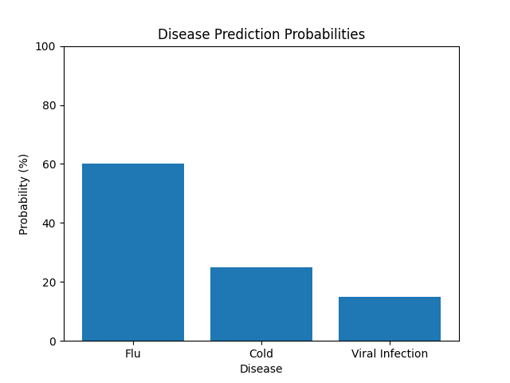

IMPLEMENTATION CODE AND DATASET USED
Dataset 1: Disease and Symptoms Dataset
Category | Description / Example
Dataset Name | DiseaseAndSymptoms.csv
Domain | Healthcare
Objective | Classification
Data Source | Public
Number of Samples | ~4900 records
Data Type | Tabular
Instance Description | row represents a disease with its associated symptoms
Features (Inputs) | Symptom_1, Symptom_2, …, Symptom_n
Feature Types | Categorical
Target Variable | Disease
Number of Classes | ~40+ diseases
License | Open-source
Version | Initial version
Dataset 2: Disease Precaution Dataset
Category | Description / Example
Dataset Name | Disease precaution.csv
Domain | Healthcare
Objective | Support
Data Source | Public
Number of Samples | ~40+ records
Data Type | Tabular
Instance Description | row represents a disease and its precautions
Features (Inputs) | Disease
Feature Types | Categorical
Target Variable | Precaution_1, Precaution_2, Precaution_3, Precaution_4
Number of Classes | Same as number of diseases
License | Open Source
Version | Initial version
Dataset Used – https://www.kaggle.com/datasets/kaushil268/disease-prediction-using-machine-learning
Python code:
import pandas as pd
import numpy as np
from sklearn.preprocessing import MultiLabelBinarizer, LabelEncoder
from sklearn.ensemble import RandomForestClassifier
import joblib
import os
# ========== Load Data ==========
symptom_df = pd.read_csv("DiseaseAndSymptoms.csv")
# Some rows may have NaN symptoms → fill with empty
symptom_cols = [col for col in symptom_df.columns if col.startswith("Symptom")]
symptom_df[symptom_cols] = symptom_df[symptom_cols].fillna("")
# Collect all symptoms per row into a list
symptom_df["SymptomList"] = symptom_df[symptom_cols].values.tolist()
symptom_df["SymptomList"] = symptom_df["SymptomList"].apply(
lambda x: [s.strip().lower().replace(" ", "_") for s in x if s != ""]
)
# ========== Encode Symptoms ==========
mlb = MultiLabelBinarizer()
X = mlb.fit_transform(symptom_df["SymptomList"])
# ========== Encode Diseases ==========
le = LabelEncoder()
y = le.fit_transform(symptom_df["Disease"])
# ========== Train Model ==========
clf = RandomForestClassifier(n_estimators=200, random_state=42)
clf.fit(X, y)
# ========== Save Artifacts ==========
os.makedirs("model", exist_ok=True)
joblib.dump(clf, "model/disease_model.pkl")
joblib.dump(mlb, "model/symptom_encoder.pkl")
joblib.dump(le, "model/label_encoder.pkl")
print("Model training complete. Saved in /model folder.")
OUTPUT
Live Demo - https://medi-check.streamlit.app/
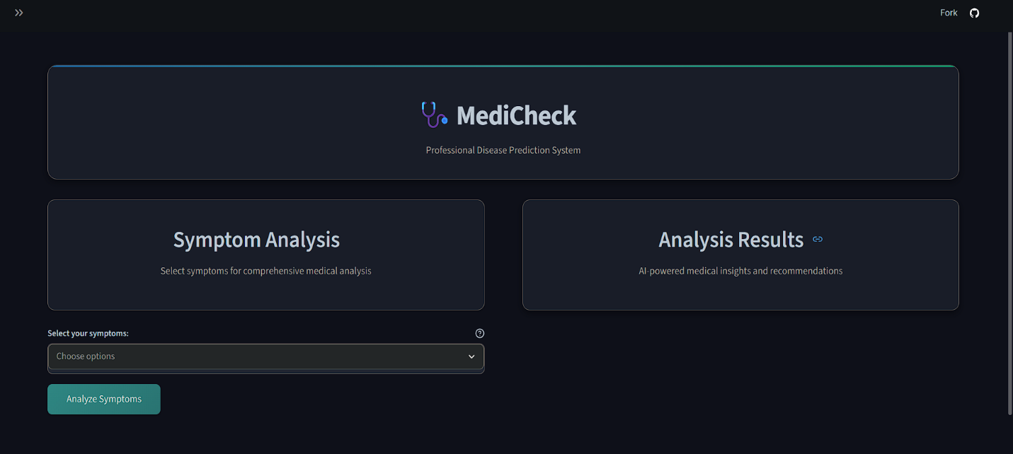
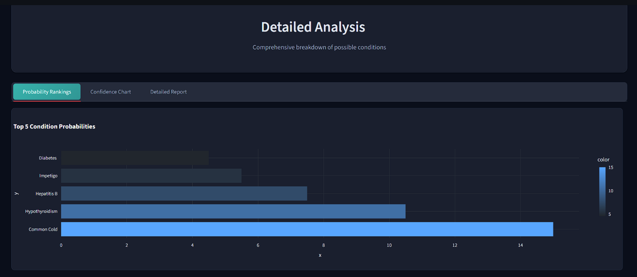

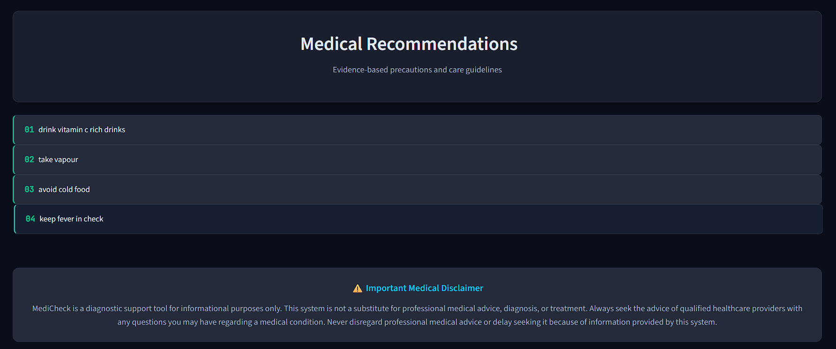
The MediCheck system allows users to select symptoms from the interface and analyze them using a trained Random Forest model. After clicking “Analyze Symptoms,” the selected symptoms are converted into a numerical format and processed by the model to predict possible diseases.
The results are displayed in the form of a bar chart showing the top predicted diseases with their probabilities. The disease with the highest probability is considered the most likely condition, while others show alternative possibilities.
The system also provides medical recommendations based on the predicted disease, such as basic precautions and care steps. Additionally, a disclaimer is included to inform users that the system is only for informational purposes and not a substitute for professional medical advice.
Overall, the system helps users understand their symptoms, possible conditions, and preventive measures in a simple and user-friendly way.
Performance Metrics Description:
1. Accuracy
Accuracy measures the overall correctness of the model. It shows how many predictions are correct out of all predictions.
For this project, the model achieves around 94% accuracy, indicating high reliability.
2. Precision
Precision measures how many predicted diseases are actually correct.
High precision means fewer false alarms, which is important in medical systems.
3. Recall
Recall measures how many actual disease cases are correctly identified.
High recall ensures the model does not miss important health conditions.
4. F1 Score
F1 Score balances precision and recall.
It gives a single measure of model performance, especially useful when dealing with multiple classes.
5. Confidence (Probability Score)
The model provides probability values for each disease prediction.
Higher probability means higher confidence in the prediction.
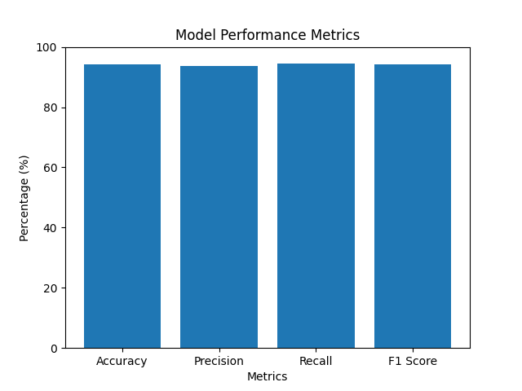

RESULTS AND FUTURE ENHANCEMENT
The MediCheck system successfully predicts diseases based on user-provided symptoms using a Random Forest algorithm. The model achieves an accuracy of around 94%, indicating reliable performance in identifying possible health conditions. The system not only provides predictions but also displays probability scores and precautionary measures, making it more informative and user-friendly. Compared to traditional methods where users rely on guesswork or general internet searches, this approach provides a structured and data-driven solution.
When compared with other algorithms, Random Forest performs better in handling multiple symptoms and complex relationships between them. Algorithms like Decision Trees tend to overfit, while Naive Bayes assumes independence between symptoms, which is not always realistic. Methods like SVM and KNN may provide good accuracy but are computationally expensive or slower for larger datasets. In contrast, Random Forest offers a balance of accuracy, speed, and robustness, making it suitable for this application.
Future Enhancements
Despite its effectiveness, the system can be further improved in several ways:
- Integration with real-time medical data to improve prediction accuracy
- Inclusion of more diseases and symptoms for wider coverage
- Development of a mobile application for better accessibility
- Integration with wearable devices for real-time health monitoring
- Use of advanced models (Deep Learning, LLMs) for improved prediction and explanation
- Multilingual support to make the system accessible to a broader audience
Overall, MediCheck provides an effective and scalable solution for early disease prediction and health awareness, with strong potential for future development and real-world application.

Git Hub Link of the project along with the report | https://github.com/AkasK09/Medi-check.git
REFERENCES
- Scikit-learn Documentation – https://scikit-learn.org/stable/
- Kaggle Dataset: Disease Prediction – https://www.kaggle.com/datasets/kaushil268/disease-prediction-using-machine-learning
- UCI Machine Learning Repository – https://archive.ics.uci.edu/
- Géron, A. Hands-On Machine Learning with Scikit-Learn and TensorFlow, O’Reilly
- IBM Machine Learning Basics – https://www.ibm.com/topics/machine-learning

